Lab Report

**Lab 02: Dynamic Routing and Access Control List**

**Subject:** Quản trị mạng và hệ thống

**Class:** NT132.N21.1

**Group Members (Group 02):**

|  |  |  |
| --- | --- | --- |
|  | **Students’s names** | **Student ID** |
| 1 | Nguyễn Trần Bảo Quốc | 21520421 |
| 2 | Nguyễn Trọng Tấn Phong | 21522460 |
| 3 | Nguyễn Thành Đăng | 21520683 |
| 4 | Trịnh Tấn Đạt | 21520714 |

|  |
| --- |
| **Self-evaluated Score** |
| **9.5** |

**Evaluation:**

|  |  |
| --- | --- |
| Total time spent | 3 days |
| Lab Task | • Task 1a,b: Phong  • Task 1c,d: Đạt  • Task 2: Quốc  • Task 3: Đăng  • Report Writing: Quốc |
| Issues *(if any)*  + Difficulty  + Recommendations |  |

Table of Contents

**A.** Lab Task 2

1. Dynamic Routing theory 2

a. What is different between Classful and Classless? 2

b. Explain why we need to use “no auto-summary” when configuring RIP.. 3

c. What does C, L ,R in the IP routing board stands for ? 3

d. Propose an ACL that prevents network access via HTTP/HTTPS protocol 3

2. Dynamic routing protocol and Access Control List on networking devices 4

a. Network devices configuring 4

b. Configure RIPv2 5

c. Enable Telnet Access on all routers 7

d. Configure Standard ACL to allow access from PC1 to LAN2 8

e. Block all traffic from LAN1 to LAN3 9

f. Configure R2 so that it only access Telnet remote from LAN3 10

3. OSPF and Access Control List 11

a. Set Banner 11

b. Network Devices Configuring 12

c. Configure OSPF 14

d. Prevent access to the LAN3 from LAN1 16

**B.** References 18

# Lab Task

## Dynamic Routing theory

### What is different between Classful and Classless?

Classful and Classless addressing are 2 approaches for network addressing:

**Classful:**

• IPv4 addresses are divided into 5 pre-defined classes (A – E) based on their octets.

• Each class has a fixed default network mask which determines the number of hosts and networks.

• Not suitable for practical use, as the pre-determined number of hosts leads to inefficient IP address utilization, where admin has to assign addresses in fixed-size blocks, regardless of the actual number of hosts.

**Classless:**

• Also known as CIDR, created to solve the disadvantages of Classful.

• More flexible subnet mask (/n), which means there is no restriction of classes.

• Support VLSM, which avoid wasting IP addresses and provide better utilization.

### Explain why we need to use “no auto-summary” when configuring RIP. What will happen if we configure RIPv2 without this command ?

By default, RIPv2 automatically summarizes subnets into major classful networks, which can lead to many problems, including packets being sent to the wrong destination.

To avoid such issues, we use the “no auto-summary” command to disable auto-summarization.

For example, if we configure “network 10.0.1.0” without “no auto-summary”, the protocol will automatically summarize this subnet as a classful subnet mask (class A in this case), leading to wrong routing information.

### What does C, L ,R in the IP routing board stands for ?

“C” stands for directly connected route, indicates that this network is directly connected to the router.

“L” stands for local route. It means the router has an IP address in the same network as the destination IP.

“R” stands for the routing protocol (RIPv2) that the router used to learn about the network.

### Propose an ACL that prevents all hosts in network 192.168.10.0/24 access the internet via HTTP/HTTPS protocol

**Router(config)#** access-list 100 deny tcp 192.168.10.0 0.0.0.255 any eq 80

**Router(config)#** access-list 100 deny tcp 192.168.10.0 0.0.0.255 any eq 443

**Router(config)#** access-list 100 permit ip any any

In this configuration, we create an ACL numbered 100, this ACL deny all network access via HTTP (port 80) and HTTPS (port 443). After that, we create another rule to permit any other traffic to pass through.

## Dynamic routing protocol and Access Control List on physical networking devices

### Network devices configuring

We are given the network 172.18.0.0/16 for this exercise.

Using the VLSM method, we get the *Subnetting table* below.

|  |  |  |  |
| --- | --- | --- | --- |
| Subnet | Network Adress /CIDR | First address | Broadcast address |
| LAN1 | 172.18.0.0/23 | 172.18.0.1 | 172.18.1.255 |
| LAN2 | 172.18.2.0/25 | 172.18.2.1 | 172.18.2.127 |
| LAN3 | 172.18.2.128/26 | 172.18.2.129 | 172.18.2.191 |
| WAN1 | 172.18.2.192/29 | 172.18.2.193 | 172.18.2.199 |
| WAN2 | 172.18.2.200/30 | 172.18.2.201 | 172.18.2.203 |

Now we can do the *Addressing table*:

|  |  |  |  |  |
| --- | --- | --- | --- | --- |
| Device | Interface | IP Address | Subnet Mask | Default Gateway |
| **R1** | G0/0 | 172.18.0.1 | 255.255.254.0 |  |
| G0/1 | 172.18.2.193 | 255.255.255.248 |  |
| **R2** | G0/0 | 172.18.2.201 | 255.255.255.252 |  |
| G0/1 | 172.18.2.195 | 255.255.255.248 |  |
| **R3** | G0/0 | 172.18.2.1 | 255.255.255.128 |  |
| G0/1 | 172.18.2.202 | 255.255.255.252 |  |
| **R4** | G0/0 | 172.18.2.129 | 255.255.255.192 |  |
| G0/1 | 172.18.2.194 | 255.255.255.248 |  |
| **PC1** | NIC | 172.18.0.10 | 255.255.254.0 | 172.18.0.1 |
| **PC2** | NIC | 172.18.2.130 | 255.255.255.192 | 172.18.2.129 |
| **PC3** | NIC | 172.18.2.10 | 255.255.255.128 | 172.18.2.1 |

### Configure RIPv2

### Enable Telnet Access on all routers

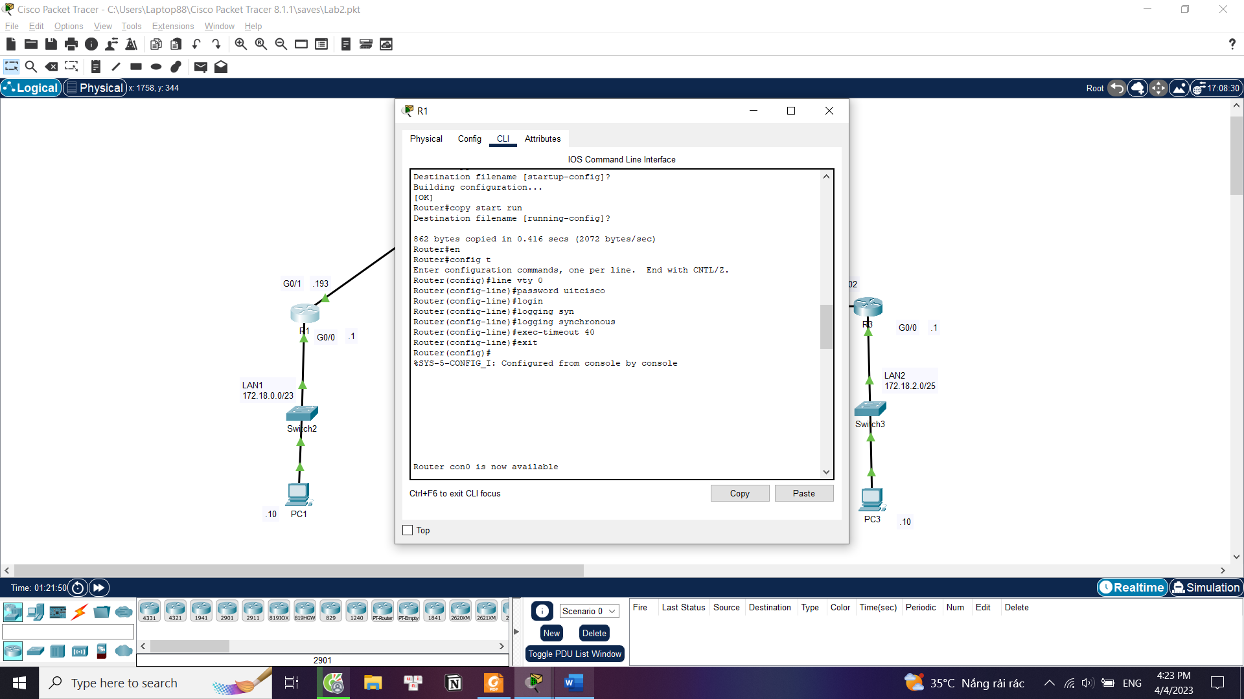

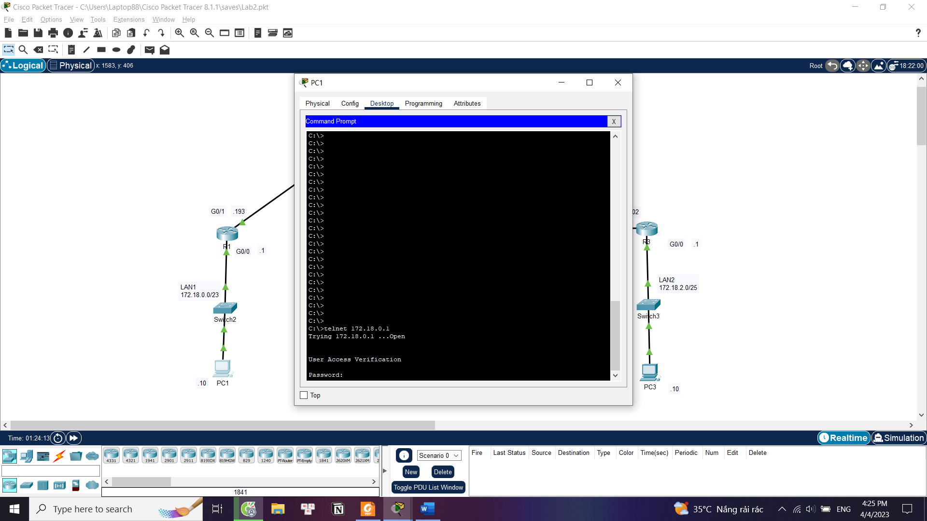

### Configure Standard ACL to allow access from PC1 to LAN2

**R3(config)#** access-list 1 permit 172.18.0.10 0.0.1.255

**R3(config)#** int g0/0

**R3(config-if)#** ip access-group 1 out

Figure 1. Configuring ACL

Now any PCs other than PC1 are unable to access LAN2.

Figure 2. PC2 fails to reach LAN2

### Block all traffic from LAN1 to LAN3

**R4(config)#** access-list 2 deny 172.18.0.0 0.0.1.255  
**R4(config)#** access-list 2 permit any

**R4(config)#** int g0/0

**R4(config-if)#** ip access-group 2 out

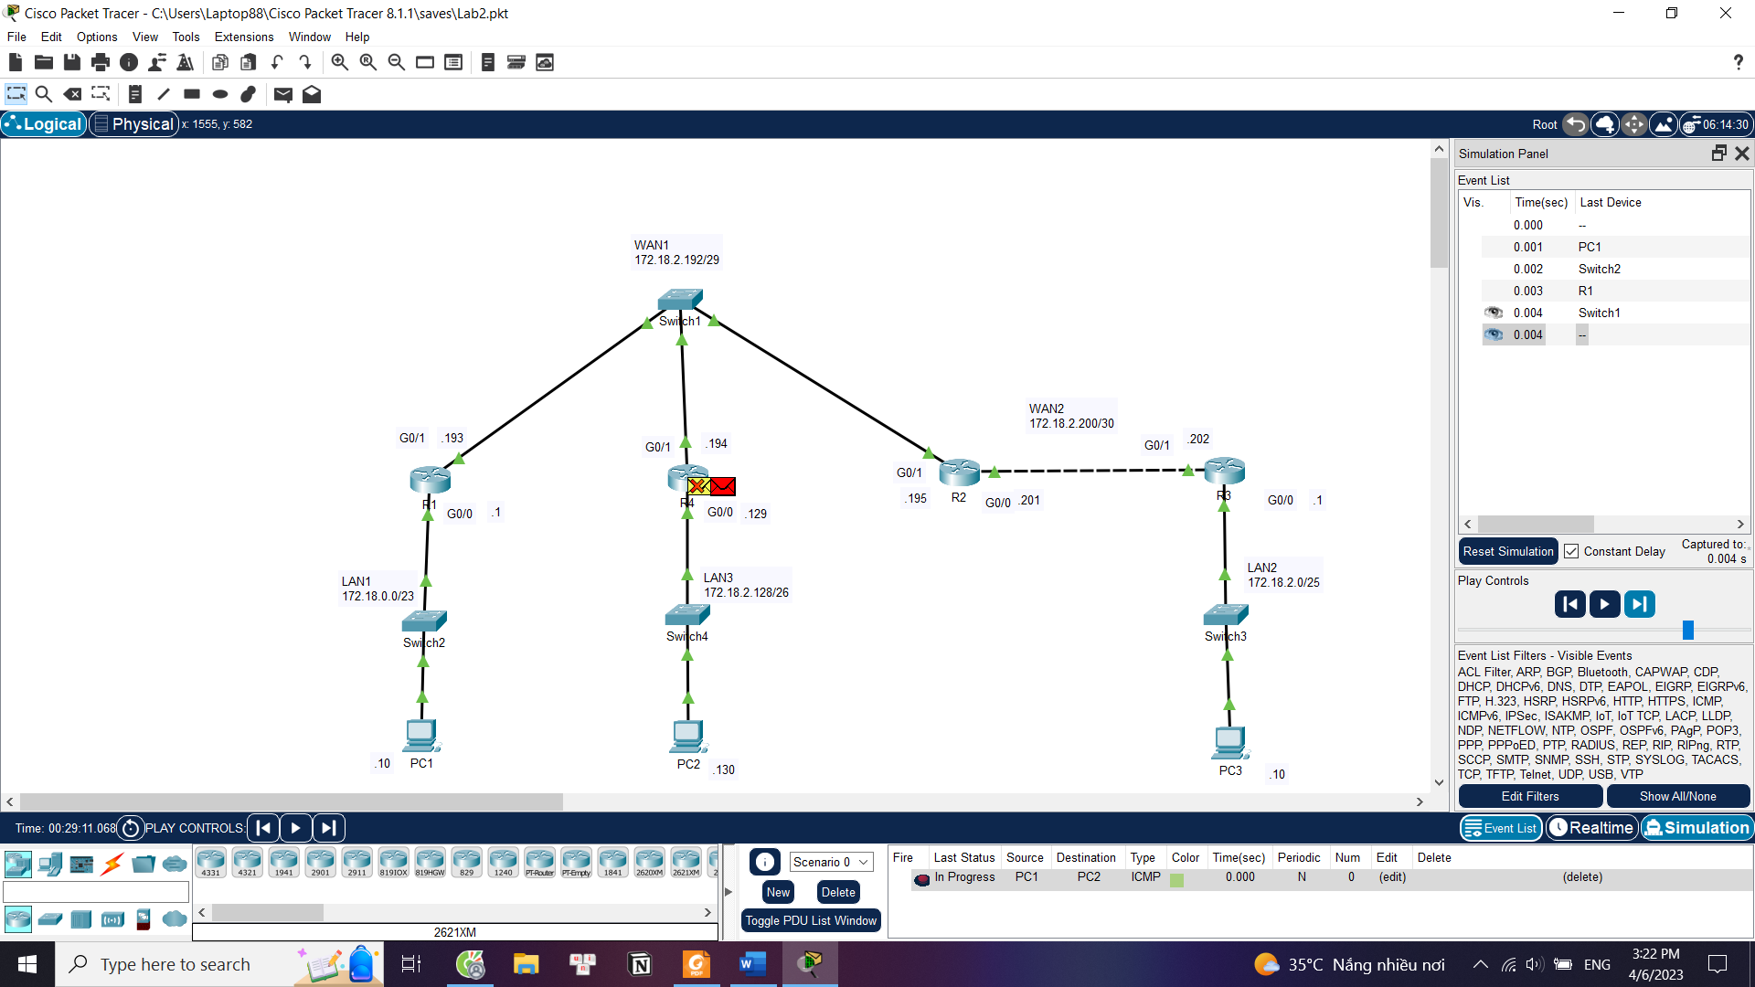

Figure 3. PC1 (LAN1) fails to reach PC2 (LAN3)

### Configure R2 so that it only access Telnet remote from LAN3

**R2(config)#** ip access-list extended TELNETL3  
**R2(config-ext-nacl)#** permit tcp 172.18.2.128 0.0.0.63 any eq telnet  
**R2(config-ext-nacl)#** deny tcp any any eq telnet

**R2(config-ext-nacl)#** permit ip any any  
**R2(config)#** int g0/1  
**R2(config-if)#** ip access-group TELNETL3 in

Figure 4 & 5. PC2 (LAN3) configuring R2 via Telnet, while PC1 fails.

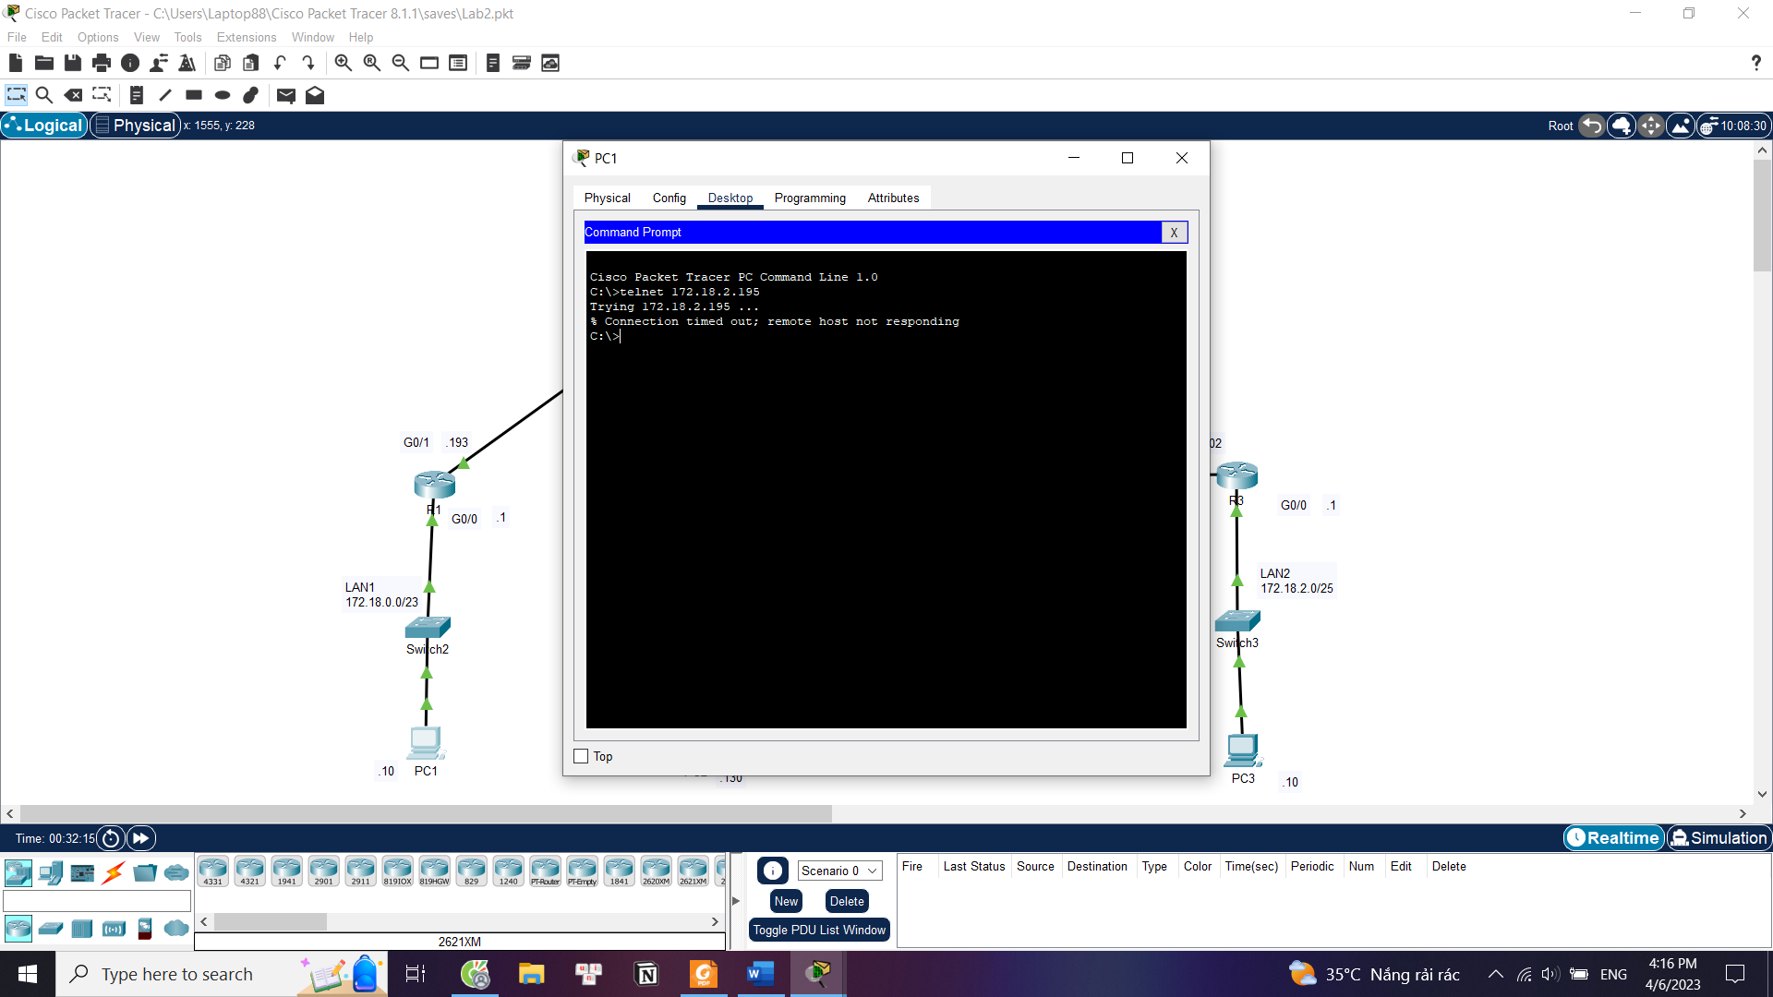

## OSPF and Access Control List

### Set Banner

### Network Devices Configuring

We are given the network 172.18.0.0/16 for this exercise.

Using the VLSM method, we get the *Subnetting table* below.

|  |  |  |  |
| --- | --- | --- | --- |
| Subnet | Network Adress /CIDR | First address | Broadcast address |
| LAN1 | 172.18.0.0/25 | 172.18.0.1 | 172.18.0.127 |
| LAN2 | 172.18.0.128/26 | 172.18.0.129 | 172.18.0.191 |
| LAN3 | 172.18.0.192/27 | 172.18.0.193 | 172.18.0.223 |
| WAN1 | 172.18.0.224/30 | 172.18.0.225 | 172.18.0.227 |
| WAN2 | 172.18.0.228/30 | 172.18.0.229 | 172.18.0.231 |
| WAN3 | 172.18.0.232/30 | 172.18.0.233 | 172.18.0.235 |
| WAN4 | 172.18.0.236/30 | 172.18.0.237 | 172.18.0.239 |

Now we can do the *Addressing table*:

|  |  |  |  |  |
| --- | --- | --- | --- | --- |
| Device | Interface | IP Address | Subnet Mask | Default Gateway |
| **HoChiMinh** | Fa0/0 | 172.18.0.1 | 255.255.255.128 |  |
| Se2/0 | 172.18.0.225 | 255.255.255.252 |  |
| Se3/0 | 172.18.0.229 | 255.255.255.252 |  |
| **HongKong** | Se2/0 | 172.18.0.226 | 255.255.255.252 |  |
| Fa0/0 | 172.18.0.129 | 255.255.255.192 |  |
| Se3/0 | 172.18.0.233 | 255.255.255.252 |  |
| **NewYork** | Se2/0 | 172.18.0.234 | 255.255.255.252 |  |
| Fa0/0 | 172.18.0.193 | 255.255.255.224 |  |
| Se3/0 | 172.18.0.237 | 255.255.255.252 |  |
| **Singapore** | Se3/0 | 172.18.0.238 | 255.255.255.252 |  |
| Se2/0 | 172.18.0.230 | 255.255.255.252 |  |
| **PC0** | NIC | 172.18.0.2 | 255.255.255.128 | 172.18.0.1 |
| **PC1** | NIC | 172.18.0.3 | 255.255.255.128 | 172.18.0.1 |
| **PC2** | NIC | 172.18.0.130 | 255.255.255.192 | 172.18.0.129 |
| **PC3** | NIC | 172.18.0.131 | 255.255.255.192 | 172.18.0.129 |
| **PC4** | NIC | 172.18.0.194 | 255.255.255.224 | 172.18.0.193 |

### Configure OSPF

### Prevent access to the LAN3 from VLAN1

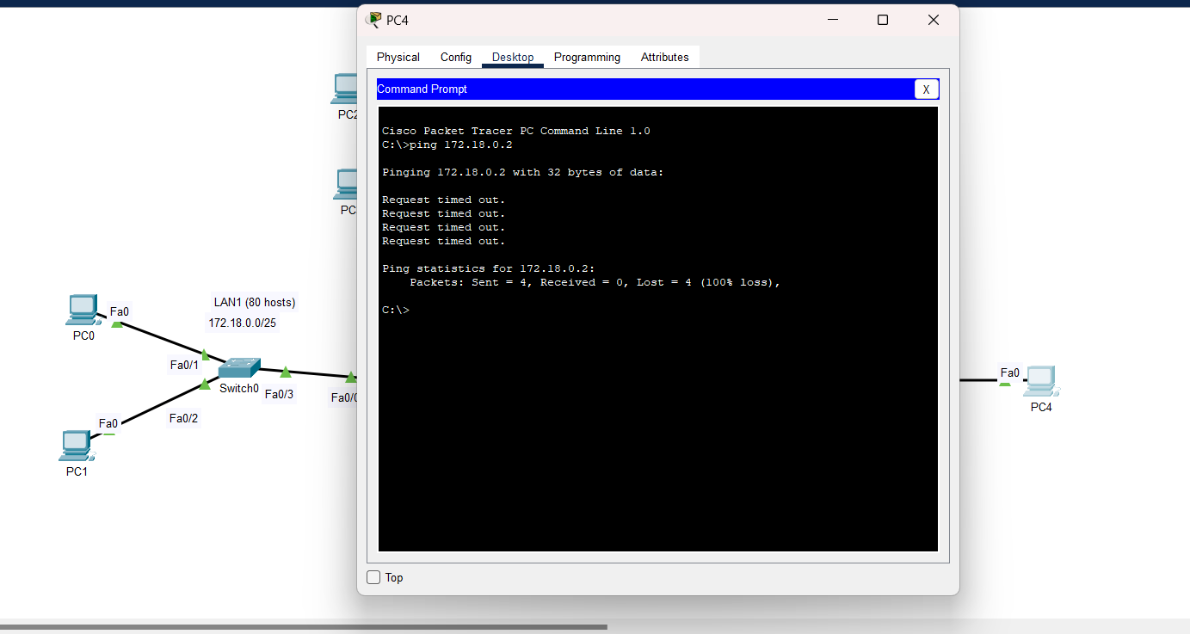

# References

Classful and Classless (Task 1a):

<https://www.geeksforgeeks.org/classful-vs-classless-addressing/>

No auto-summary (Task 1b):

<https://www.omnisecu.com/cisco-certified-network-associate-ccna/auto-summarization-in-rip.php>

C, L, R meaning (Task 1c):

<https://community.cisco.com/t5/networking-knowledge-base/local-host-routes-in-the-routing-table/ta-p/3115431>